Custom birth announcement gifting orders

Stage 1: Gift selection

Inquiry received Via store, website, WATI, instagram etc
  - Add the custom to CRM using this form:
Type of client : Bulk Gifting ; Additional notes: Birth announcements

Asset: Form link
https://forms.zohopublic.in/wareinnovationsllp1/form/StoreWalkins/formperma/u6QFN3VbiwXq_iXrY8vT2VOWHlO-G3koOw3VHa4Mve4

Understand their requirement:
  - Send them following message, understanding their requirements & needs

Asset: Message 1:
Hello {{Name}},
Thank you for reaching out to Ware for such a special celebration! ✨
First and foremost, congratulations on the baby! 👶💛

Asset: Message 2:
To help you find the perfect birth announcement gift, I’d love to know a few details:
- What is your timeline for gifting?
- Do you have a budget in mind per gift?
- How many gifts will you need?
- Would you like a custom gift box?
- Are you considering adding any food items along with the ware?
- If you have any references or a vision in mind, feel free to share them with me!
Looking forward to helping you create something meaningful!😊

  - Instead of sending a catalog & overwhelming them with too many options. We will send them 5 options based on on their requirements in the following format:

Asset: PDF format
(include 5 options that fit their budget along with the packaging photo, keep it prepared for easy communication)

Canva template:
https://www.canva.com/design/DAGg1hz2iTM/g-LAb7sWr2afJ5WFbcflrw/edit?utm_content=DAGg1hz2iTM&utm_campaign=designshare&utm_medium=link2&utm_source=sharebutton
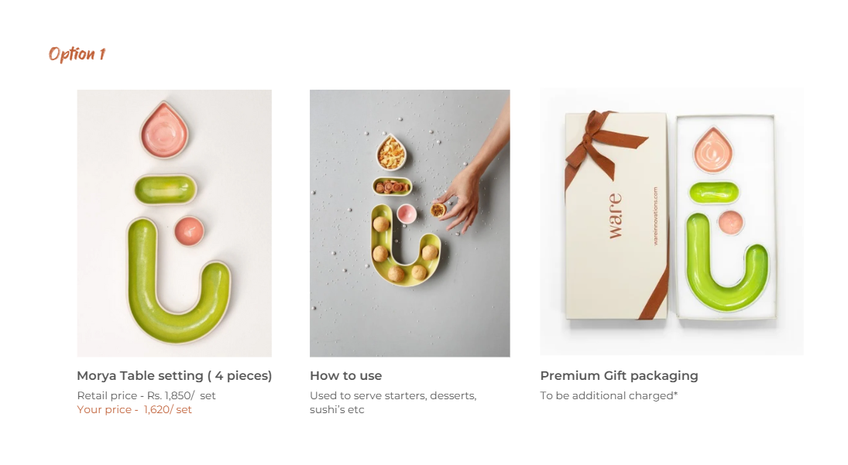
  - For customers who have shown interest in customized boxes. Share a document with all the information (design customization, charges etc) that can be shared with them

Asset: PDF document
Canva template:
https://www.canva.com/design/DAGg1nERuow/JXZXOI2KejrgH0VvGNIXDw/edit?utm_content=DAGg1nERuow&utm_campaign=designshare&utm_medium=link2&utm_source=sharebutton

Customer FAQ that need to be addressed at this stage

 | Questions | Answer
1 | What are your discounts? | Our discounts are based on the order value & Moq  > 1 lac - 12% (max)  1 - 1.5 lac - 15% (max)  1.5 - 3 lac - 20% (max)  3 lac < - 25% (max)
2 | How will the products be packed? | Address in the options sent
3 | I want a custom box, what is the process for that, can i give you the design for it? | Addressed in customization document made
4 | Product colour customization | I am sorry we don’t offer product customization! However we can curate a set that has colour you like in it to match your needs!
5 | I want to ship to multiple address, will you do that for me? | Yes, we offer multi address shipping
6 | I am looking to add food with the set? Do you have any suggestions? | Addressed in customization document made

Gift selected & reference for packaging sent

  - Send customers a timeline breakdown which includes the following. We need go back from their expected date and set a deadline for decisions
    - Final product selection date:
    - Box artwork timeline - (2 days)
    - Sampling payment date
    - Box sampling timeline- (4 days)
    - Food required by
    - 50% advance payment timeline
    - Production timeline (ware)
    - Production timeline (boxes) - 45 days ( if not in production)
    - Packaging timeline - 10 days
    - Remaining 50% payment timeline
    - Shipping timeline - (depends on the location)

Asset: Whatsapp Message
Draft message sent Rushika to be added

  - Ask customer to choose a preferred style for box & and send reference for a custom design

Asset: Whatsapp Message
Hey {{Name}}, 😊
Please take a look at the box customization options and let me know which one you like best! 🎁✨
If you have a reference—like a baby announcement artwork you’ve shared with your family—and would love the box to match that, feel free to send it over! We’d be happy to design it for you. 💛
  - If the packaging foam/ box had to be custom made for a product then send an email to packaging team requesting following things
    - Explain how the product has to packed & get a render from - Shlok
    - Size of the box - Shlok
    - Cost of the foam & Box - Fahad

Stage 2: Sampling & Customization

Box artwork design approval
- Once a customer sends the reference/ or picks a pre-existing template. Create an iteration and send the customer a pdf with all the creatives that will be approved.
Price of the packaging to be included in the PDF

Asset: PDF format

Canva
https://www.canva.com/design/DAGgvU-QnmI/XKGIbJ5mEHoNR6V_aNUkGQ/edit?utm_content=DAGgvU-QnmI&utm_campaign=designshare&utm_medium=link2&utm_source=sharebutton

Customer FAQ that need to be addressed at this stage

 | Questions | Answer
1 | Can the cost of the boxes be reduced? | We charge the actual cost to you so if you increase your quantity then we can try to get your cost to be lower!
2 | Can the packaging cost be without GST | Yes, you can pay us in cash

Sampling cost & Payment

  - Send a quote to the customer that includes the following
    - Product
    - Customization fee
    - Packaging cost ( if they are paying for gst)

  - Get the payment for Customization

Box sampling

  - Once the sampling payment is done. Inform the packaging to start with the sampling process
    - Only 2 sample is free, the rest will be chargeable - 1000 / - each

  - If food is involved. The packaging for it needs to be sampled at this stage
    - Either we send the products to them & they can let us know how they want the food to be ( charge the shipping)
    - Or they can send the food here for us to sample

  - Once the final sample is confirmed, send an email to the inventory with the instructions of how to pack the sample. And ask them to send a video of the packaging
    - Include images of the food
    - What products need to go in
    - Send note & guest name tag printed

  - Send the video to the client for their approval on the packaging. All the changes in the packaging need to be made at this stage.

50% installment payment
  - Once the samples & packaging is approved send the customer a message requesting 50% advance payment

Asset: Whatsapp Message
Hey {{Name}}, 😊
Now that the sampling is done & approved, we wanted o go ahead and start the production process!

For that, you will have to do 50% advance of the entire amount that is {{enter the amount}} payment.

Let me know your preferred mode of payment!
Requesting you to get this done as soon as possible! So that we can start the production & deliver on time!

  - Once the payment is done, send an email to the packaging team and inform them to start the production process.

Stage 3: Order Fulfilment & Shipping

Guestlist & Addresses

  - Once the packaging & products are in production. Send the customer a google sheet to fill in their guestlist & address if applicable.

Asset: Google Sheet File
https://docs.google.com/spreadsheets/d/11LNdCLXuhXw3m12bqL8O4phve1aVkAaUYFD4iJiV1I4/edit?usp=sharing

Asset: Message( not shipping to multiple addresses)
Hey {{Name}}, 😊
I am sharing a google sheet with you, for your guestlist. Please fill in and send as soon as possible! So that we can get started with the printing!
Asset: Message( shipping to multiple addresses)
Hey {{Name}}, 😊
I am sharing a google sheet with you, for your guestlist.
Please fill in the following information, the name of your guest, their full address along with a contact number that the delivery partner can call in case they are having trouble finding the address!
We will add the shipping cost at actuals in the same sheet along with the tracking details & expected delivery date so that you can keep a track of the gifts!

  - Share the filled sheet with Mansi and ask them to fill in the shipping rates & delivery timeline.

Order Packaging

  - While the order is getting packed, Vishnu has to be instructed to take a video of the packaging
    - 9:16 video of product being packed from end to finish
    - 9:16 video of the stack of product packed + lineup in inventory of the team packaging

  - Once the video is shot, it needs to uploaded on the drive folder here

Asset : Drive link

50% pending payment + shipping cost (Second Installment)

  - One the production has arrived the the customer needs to pay the remaining 50% before the product goes out

Asset: Whatsapp Message
Hey {{Name}}, 😊
Good news! All the packaging & the products have arrived and ready!
My team will start packing soon!
Please make the pending payment {{amount}}. As soon as its done we will start shipping the pieces!

Shipping
  - Once the payment is done, shipping can start. If the order is going to multiple addresses, then the client needs to be informed before any order is being shipped so that they guest can be informed and we don’t get any order back

Asset: Whatsapp Message
Hey {{Name}}, 😊
We are going to start shipping! Just a request if you can inform the guests that they will be expecting a delivery at the time (mentioned in the sheet)

Stage 4: Post Fulfillment

Client Review
  - Once the order is done and shipped we need to send a request for a review to the client. Either it can be a video or a message review or google reviews

Asset: Whatsapp Message
Hey {{Name}}, 😊

Asset: Review link

Make a social media plan for posting a Reel about it

